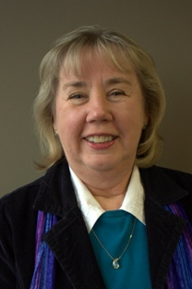

Nancy Doughty, LICSW
Senior Care Consultant
Lighthouse Care Management

Nancy earned her Master of Social Work degree from Eastern Washington University. She trained and worked at the Department of Social and Health Services, Group Health Northwest, St. Luke’s Extended Care and Deaconess Hospital. She has extensive experience as a geriatric care manager. She has experience working with dementia, grief and loss, behavioral issues, and transition.

Nancy has extensive knowledge of community resources, assessments, and medical issues common to seniors. She is also a trained and compassionate mental health counselor. She is licensed in Washington State as a clinical social worker (LICSW). She is also an Advanced Certified Social Worker Case Manager (ACSWCM). She is a member in good standing with the National Association of Social Workers and the National Association of Professional Geriatric Care Managers. She has owned Lighthouse Care Management for over 10 years.

