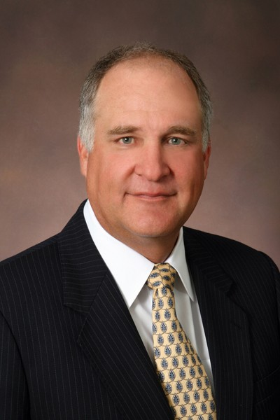 |  | Thomas M. Forrest, CPA  President & CEO  U.S. Trust Company of Delaware  Phone: 302-432-6703

Thomas M. Forrest, CPA is President & CEO of U.S. Trust Company of Delaware.

Tom is past President and founder of the Personal Trust Division for Charles Schwab Bank in Wilmington, Delaware. He opened and staffed the Schwab personal trust office in 2007. Before joining Charles Schwab, Tom was co-founder, President and CEO of U.S. Trust Company of Delaware. Tom joined U.S. Trust Company in 1999 and opened the U.S. Trust office in Delaware in 2000, where he managed the office through 2007. Tom was manager of the First Union Trust Company, Delaware office prior to joining U.S. Trust.

Prior to joining First Union, Tom was Vice President and Manager of the Trust Tax and Financial Planning Division for Wilmington Trust for 18 years. Mr. Forrest is a past President of the National Association of Estate Planners and Councils, past President of the Delaware Estate Planning Council, past Treasurer of the Delaware Society of CPA’s and past Chairman of the Tax Committee. Tom is a past board member of the Society of Financial Service Professionals, Delaware Chapter and has served as a board member of the Philadelphia Estate Planning Council. He is also a past President of the Bank and Trust Tax Association of Mid-Atlantic States, a member of the American Institute of CPAs, The Delaware Society of CPAs, and The Wilmington Tax Group. Tom is past treasurer and board member of the National Conference of Christians and Jews, Delaware Chapter and currently serves on the board of Autism Delaware and is the current Chairman of The Mary Campbell Center Foundation.

Mr. Forrest assisted the IRS with the development of fiduciary income tax returns on magnetic media and became the first bank in the country to file fiduciary income tax returns on magnetic media. Mr. Forrest has lectured to professional groups on a variety of tax and estate planning topics at numerous meetings and seminars around the county including the National Graduate Trust School, ABA Tax Compliance Seminar, Financial Planning Association, American Bar Association Tax Section Meetings, Pennsylvania Bar Institute, Bank Administration Institute, and The National Association of Estate Planners and Councils.

Tom graduated from the University of Delaware in 1982 with a B.S. in Accounting, and received his M.S. in Taxation from Widener University in 1985. He received his Certified Public Accountant Certificate in 1986 and Accredited Estate Planner in 1995. Tom received the National Association of Estate Planners & Councils 2005 Distinguished Accredited Estate Planner award.

